## Projektni tim: Davor Pernjek

## 

## Portfolio serije Game of Thrones

## Projektna dokumentacija za projekt iz Multimedijskih sustava PITUP

## Ak.god. 2019.-2020.

**Sadržaj:**

1. Opći prikaz multimedijske aplikacije
2. Prikaz proces razvoja multimedijske aplikacije
   1. Prikupljanje zahtjeva i analiza problema
   2. Inicijalni prijedlog web dizajna
   3. Faza dizajna ili projektiranja
   4. Faza razvoja ili programiranja
   5. Faza testiranja
   6. Faza implementacije

# Opći prikaz multimedijske aplikacije

|  |  |
| --- | --- |
| Naziv aplikacije | Portfolio serije Game of Thrones |
| Autori | Davor Pernjek |
| Uloge autora | D. Pernjek – prikupljanje zahtjeva i analiza, inicijalni prijedlog, dizajniranje, razvijanje web mjesta i unos sadržaja, testiranje i dorada, implementacija |
| Složenost sustava | 24 web stranica s galerijom slika i responzivnim dizajnom |
| Mjesto pohrane/prikaza aplikacije | Moodle |
| Uključene tehnologije | HTML, CSS, JavaScript, Bootstrap okvir |
| Uključeni alati | Adobe Photoshop, Sublime Text3 |
| Copyright informacije | © Game of Thrones Wiki: Naslovna slika, URL: <https://gameofthrones.fandom.com/f/p/3343172654596377113/r/3344233352137926283> |
|  | © Game of Thrones Wiki: Bronn's house sigil, URL: <https://gameofthrones.fandom.com/wiki/Bronn%27s_house> |
|  | © Game of Thrones Wiki: House Arryn sigil, URL: <https://gameofthrones.fandom.com/wiki/House_Arryn> |
|  | © Game of Thrones Wiki: House Baratheon sigil, URL: <https://gameofthrones.fandom.com/wiki/House_Baratheon> |
|  | © Game of Thrones Wiki: House Greyjoy sigil, URL: <https://gameofthrones.fandom.com/wiki/House_Greyjoy> |
|  | © Game of Thrones Wiki: House Lannister sigil, URL: <https://gameofthrones.fandom.com/wiki/House_Lannister> |
|  | © Game of Thrones Wiki: House Martell sigil, URL: <https://gameofthrones.fandom.com/wiki/House_Martell> |
|  | © Game of Thrones Wiki: House Stark sigil, URL: <https://gameofthrones.fandom.com/wiki/House_Stark> |
|  | © Game of Thrones Wiki: House Tully sigil, URL: <https://gameofthrones.fandom.com/wiki/House_Tully> |
|  | © Game of Thrones Wiki: House Frey sigil, URL: <https://gameofthrones.fandom.com/wiki/House_Frey> |
|  | © Game of Thrones Wiki: House Bolton sigil, URL: <https://gameofthrones.fandom.com/wiki/House_Bolton> |
|  | © Game of Thrones Wiki: House Tyrell sigil, URL: <https://gameofthrones.fandom.com/wiki/House_Tyrell> |
|  | © Game of Thrones Wiki: House Targaryen sigil, URL: <https://gameofthrones.fandom.com/wiki/House_Targaryen> |
|  | © Game of Thrones Wiki: Season 1 poster, URL: <https://gameofthrones.fandom.com/wiki/Season_1> |
|  | © Game of Thrones Wiki: Season 2 poster, URL: <https://gameofthrones.fandom.com/wiki/Season_2> |
|  | © Game of Thrones Wiki: Season 3 poster, URL: <https://gameofthrones.fandom.com/wiki/Season_3> |
|  | © Game of Thrones Wiki: Season 4 poster, URL: <https://gameofthrones.fandom.com/wiki/Season_4> |
|  | © Game of Thrones Wiki: Season 5 poster, URL: <https://gameofthrones.fandom.com/wiki/Season_5> |
|  | © Game of Thrones Wiki: Season 6 poster, URL: <https://gameofthrones.fandom.com/wiki/Season_6> |
|  | © Game of Thrones Wiki: Season 7 poster, URL: <https://gameofthrones.fandom.com/wiki/Season_7> |
|  | © Game of Thrones Wiki: Season 8 poster, URL: <https://gameofthrones.fandom.com/wiki/Season_8> |
|  | © Game of Thrones Wiki: Galerija, slika 1, URL: <https://gameofthrones.fandom.com/wiki/Gallery:_Dragons?file=706_Dragons_Army_of_the_Dead.jpg> |
|  | © Game of Thrones Wiki: Galerija, slika 2, URL: <https://gameofthrones.fandom.com/wiki/Gallery:_Dragons?file=Dragonstone_S8_EP4.jpg> |
|  | © Game of Thrones Wiki: Galerija, slika 3, URL: <https://gameofthrones.fandom.com/wiki/Gallery:_Dragons?file=Tyrion_meets_dragons.png> |
|  | © Game of Thrones Wiki: Galerija, slika 4, URL: <https://gameofthrones.fandom.com/wiki/Gallery:_Dragons?file=Rhaegal_On_Dragonstone.png> |
|  | © Game of Thrones Wiki: Galerija, slika 5, URL: <https://gameofthrones.fandom.com/wiki/Gallery:_Dragons?file=Rhaegal.jpg> |
|  | © Game of Thrones Wiki: Galerija, slika 6, URL: <https://gameofthrones.fandom.com/wiki/Gallery:_Dragons?file=Night_king_rides_viserion.jpg> |
|  | © Game of Thrones Wiki: Galerija, slika 7, URL: <https://gameofthrones.fandom.com/wiki/Gallery:_Dragons?file=706_Night_King_Viserion.jpg> |
|  | © Game of Thrones Wiki: Galerija, slika 8, URL: <https://gameofthrones.fandom.com/wiki/Gallery:_Dragons?file=Dead_viserion_by_giuseppedirosso-dbmadu1.jpg> |
|  | © Game of Thrones Wiki: Galerija, slika 9, URL: <https://gameofthrones.fandom.com/wiki/Gallery:_Dragons?file=GoT_-_In_Memoriam_Ep_5_-_viserion.jpg> |
|  | © Game of Thrones Wiki: Galerija, slika 10, URL: <https://gameofthrones.fandom.com/wiki/Gallery:_Dragons?file=Drogon_Goat_take_out.jpg> |
|  | © Game of Thrones Wiki: Galerija, slika 11, URL: <https://gameofthrones.fandom.com/wiki/Gallery:_Dragons?file=Drogon_S8_Ep6_02.jpg> |
|  | © Game of Thrones Wiki: Galerija, slika 12, URL: <https://gameofthrones.fandom.com/wiki/Gallery:_Dragons?file=Drogon_S8_Ep6_01.jpg> |
|  | © Film Cram!: Video: sažetak sezone 1, URL: <https://www.youtube.com/watch?v=2bH6VN_Gc_o&feature=emb_title> |
|  | © Film Cram!: Video: sažetak sezone 2, URL: <https://www.youtube.com/watch?v=2THvwbiMRQ8&feature=emb_title> |
|  | © Film Cram!: Video: sažetak sezone 3, URL: <https://www.youtube.com/watch?v=ATodzqT1WfQ&feature=emb_title> |
|  | © Film Cram!: Video: sažetak sezone 4, URL: <https://www.youtube.com/watch?v=Gzl45Wsbnf8&feature=emb_title> |
|  | © Film Cram!: Video: sažetak sezone 5, URL: <https://www.youtube.com/watch?v=yFZRDt5y-zQ&feature=emb_title> |
|  | © Film Cram!: Video: sažetak sezone 6, URL: <https://www.youtube.com/watch?v=DfF34kmgjEk&feature=emb_title> |
|  | © Film Cram!: Video: sažetak sezone 7, URL: <https://www.youtube.com/watch?v=FktFMYC_A2M&feature=emb_title> |
|  | © GamesRadar: Video: sažetak sezone 8, URL: <https://www.youtube.com/watch?v=_-HMQUinlLM&feature=emb_title> |
|  | © TopPng: Logo navigacija, URL: <https://toppng.com/photo/184923/ot-telletale-games-ep-01-600x315-game-of-thrones-mug-classic-logo-official-boxed> |

Vremenski tijek izrade multimedijske aplikacije:

|  |  |  |  |  |
| --- | --- | --- | --- | --- |
| **Broj** | **Datum** | **Ime autora** | **Provedene aktivnosti** | **Utrošeno sati** |
| 1. | 26.12.2019. | D. Pernjek | Prikupljanje zahtjeva | 2 |
| 2. | 26.12.2019. | D. Pernjek | Analiza problema | 2 |
| 3. | 26.12.2019. | D. Pernjek | Pisanje dokumentacije | 1 |
| 4. | 27.12.2019. | D. Pernjek | Struktura informacija i navigacija | 2 |
| 5. | 27.12.2019. | D. Pernjek | Izrada predložaka | 4 |
| 6. | 28.12.2019. | D. Pernjek | Odabir boja i fonta | 1 |
| 7. | 28.12.2019. | D. Pernjek | Pisanje dokument | 1 |
| 8. | 28.12.2019. | D. Pernjek | Dizajniranje | 6 |
| 9. | 29.12.2019. | D. Pernjek | Razvijanje | 4 |
| 10. | 2.1.2020. | D. Pernjek | Razvijanje | 4 |
| 11. | 3.1.2020. | D. Pernjek | Razvijanje | 4 |
| 12. | 4.1.2020. | D. Pernjek | Pisanje dokumentacije | 2 |
| 13. | 5.1.2020. | D. Pernjek | Testiranje | 1 |
| 14. | 5.1.2020. | D. Pernjek | Implementacija | 1 |
| 15. | 5.1.2020 | D. Pernjek | Pisanje dokumentacije | 1 |
|  |  |  | **Ukupno sati** | 36 |

|  |  |
| --- | --- |
| Problemi kod razvoja aplikacije | 1. Kod rezolucije za mobitele nije se prikazivala ikona za otvaranje navigacije, to je riješeno tako što je dodan breakpoint u CSS-u kod kojeg se visina navigacije povećava te na taj način se i ikona u navbar-u prikazuje ispravno. 2. Klikom na ikonu za otvaranje izbornika se ništa ne događa, to je zbog toga što poveznica za vanjsku knjižnicu jQuery nije bila ispravna, problem je riješen kad sam stavio ažuriranu poveznicu. 3. Kod korištenja anchor poveznica stranica se pomakne previše prema dole te se zbog toga ne vidi naslov sekcije. Problem je riješen tako što sam kreirao poseban CSS klasu za te poveznice u kojem sam stavio gornju marginu u minus, iznos margine ovisi o vrsti uređaja koja se koristi jer meni koji prekriva naslov je različite visine kod različitih uređaja. 4. Kartice sekundarnih izbornika se ne nisu poravnavale kako je trebalo, pa sam pomoću grid sustava unutar bootstrap-a kreirao poseban layout za te kartice koje se sada lijepo poravnavaju na bilo kojoj rezoluciji. 5. Kreiranje predložka u Expression Web-u nije bilo moguće jer onda bootstrap nije radio. |
| Ocjena: 4 | Sa stajališta dizajnera dobre strane su te što je web mjesto responzivno i jednostavno uz moderan dizajn, nedostatak je taj što se nije koristilo veći broj nijansi odabranih boja. Sa stajališta korisnika je aplikacija dobra po tome što se sadržaj može pronaći brzo i lako, a nedostatak je taj što nedostaje sadržaja. |
| Perspektiva: 3 | Daljni razvoj aplikacije je otežan jer ukoliko se dodaju neke nove stranice potrebno je promjeniti navigaciju, što znači da bi to trebalo promijeniti na svakoj stranici. Implementacijom ovog dizajna u neki CMS bi se taj problem mogao riješiti i na taj način poboljšati aplikacija. |

# Prikaz proces razvoja multimedijske aplikacije

* 1. **Prikupljanje zahtjeva i analiza problema** 
     1. ***Prikupljanje zahtjeva***

Kako bi se prikupili zahtjevi za izradu portfelja Game of Thrones serije, kreirana je anketa u Google obrascima. Anketirano je ukupno 7 osoba, od kojih su neke gledale seriju, a neke nisu. Ispod se nalaze odgovori ispitanika.

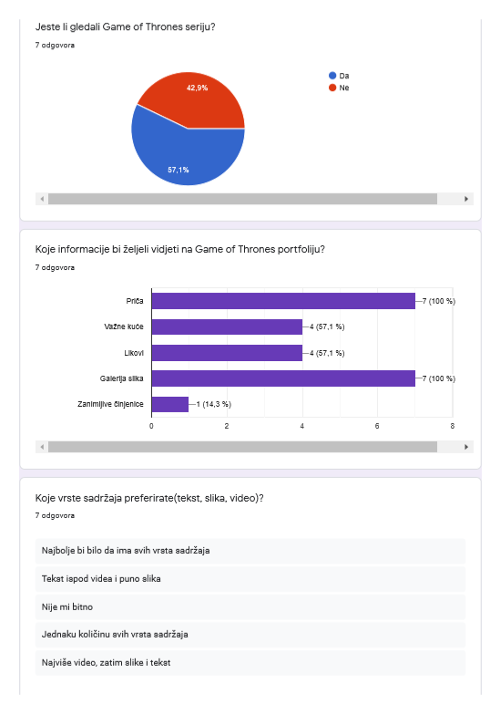

Slika 1 Anketa 1

Iz Slike 1 se može vidjeti da je anketirano 7 osoba od kojih su 4 gledale seriju. Najpoželjniji sadržaji su o priči i galerija slika, dok informacije o kućama i likovima dijele drugo mjesto. Iz ovog sam zaključio da će web mjesto sadržavati informacije o priči i važnim kućama te će sadržavati i galeriju slika. Stranice o likovima se neće kreirati jer bi za to bilo potrebno više do 30 stranica. Web mjesto će također sadržavati tekst, slike i video pošto su odgovori sadržavali sve medije.

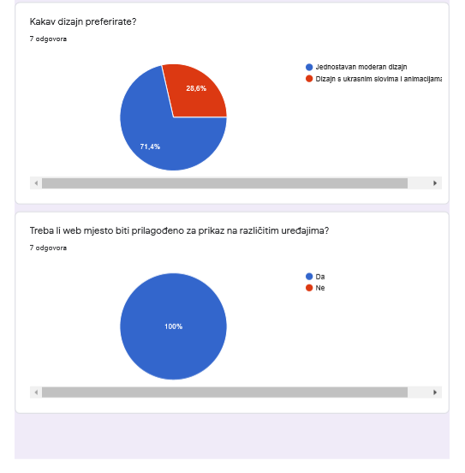

Slika 2 Anketa 2

Na gornjoj slici se može vidjeti da korisnici preferiraju jednostavna dizajn, a ne dizajn s puno ukrasnih slova i nepotrebnih animacija. Također svi korisnici žele da je web mjesto responzivo kako bi se moglo pregledavati na svim uređajima.

* + 1. ***Analiza zahtjeva i problema***

Pretraživanjem na internetu sam pronašao Game of Thrones wiki stranicu na kojoj se nalaze sve informacije o seriji kao i o knjigama. U nastavku ću analizirati to web mjesto.

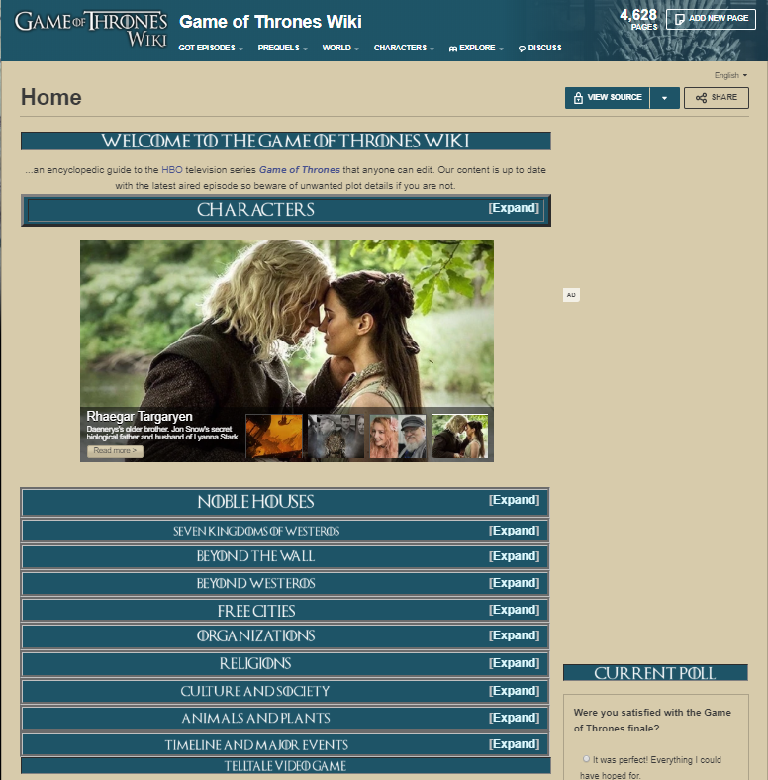

Slika 3 Game of Thrones Wiki (<https://gameofthrones.fandom.com/wiki/Game_of_Thrones_Wiki>)

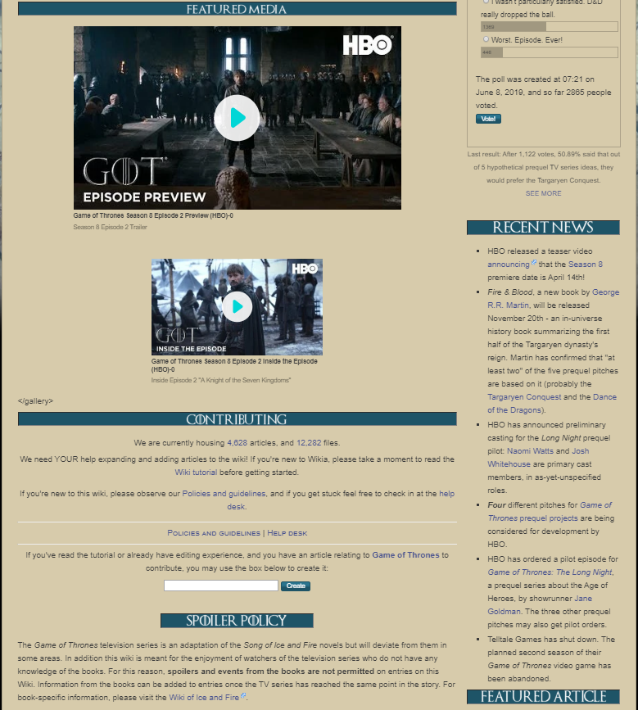

Slika 4 Game of Thrones WIki (<https://gameofthrones.fandom.com/wiki/Game_of_Thrones_Wiki>)

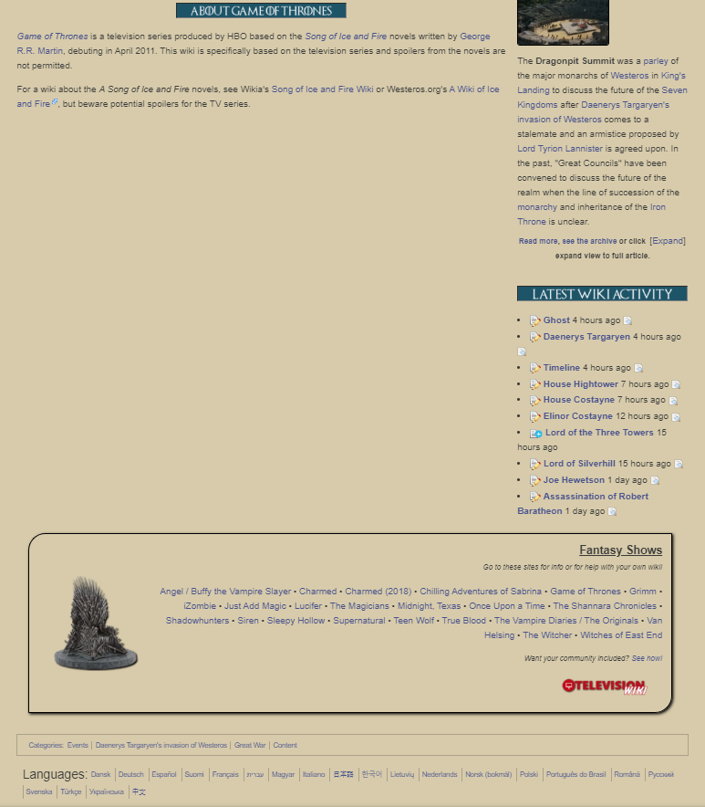

Slika 5 Game of Thrones Wiki (https://gameofthrones.fandom.com/wiki/Game\_of\_Thrones\_Wiki)

Analiziranjem Game of Thrones Wiki stranica sam došao do zaključka da sadrži mnogo informacija, ali te informacije nisu dobro raspoređene i teško ih je pronaći. Osim toga dizajn je jako loš, na primjer jedan video je širok koliko i stranica, a drugi je upola manji. Zbog trake sa sadržajem koja se nalazi sa strane se događa da sekcija s glavnim sadržajem ostaje prazna što znači da postoji mnogo neiskorištenog prostora. Iz dizajna ovog web mjesta sam zaključio da web mjesto koje izrađujem treba biti jednostavno i da se lako pretražuje sadržaj.

Sadržaj koji se nalazi na gornjoj stranici je pod CC BY-SA licencom što znači da je dozvoljeno korištenje za ponovnu upotrebu. Pošto je sadržaj iste tematike kao i moje web mjesto, odlučio sam da ću koristiti najviše koristiti taj sadržaj jer se sve nalazi na jednom mjestu i tako mi olakšava pronalaženje.

* 1. **Inicijalni prijedlog web dizajna**
     1. ***Struktura informacija i navigacija***

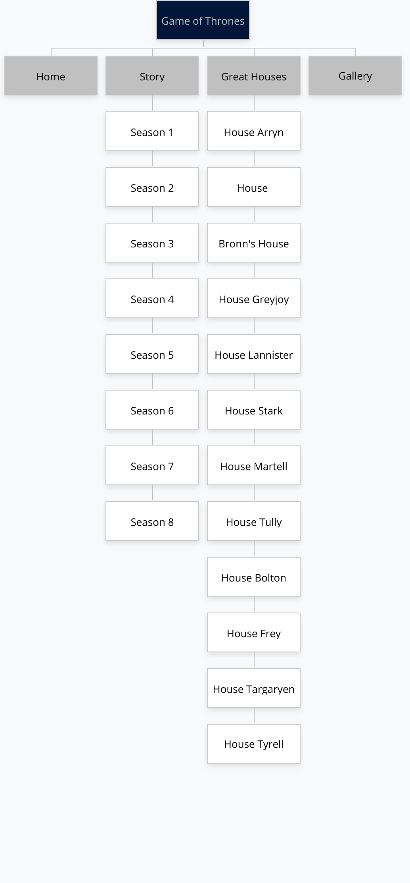

Slika 6 Struktura web mjesta

Predložak 1:

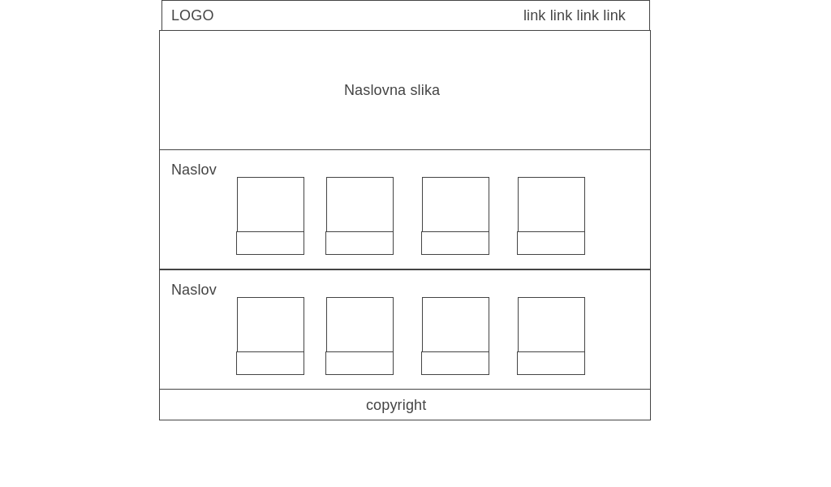

Slika 7 Predložak 1, naslovna stranica

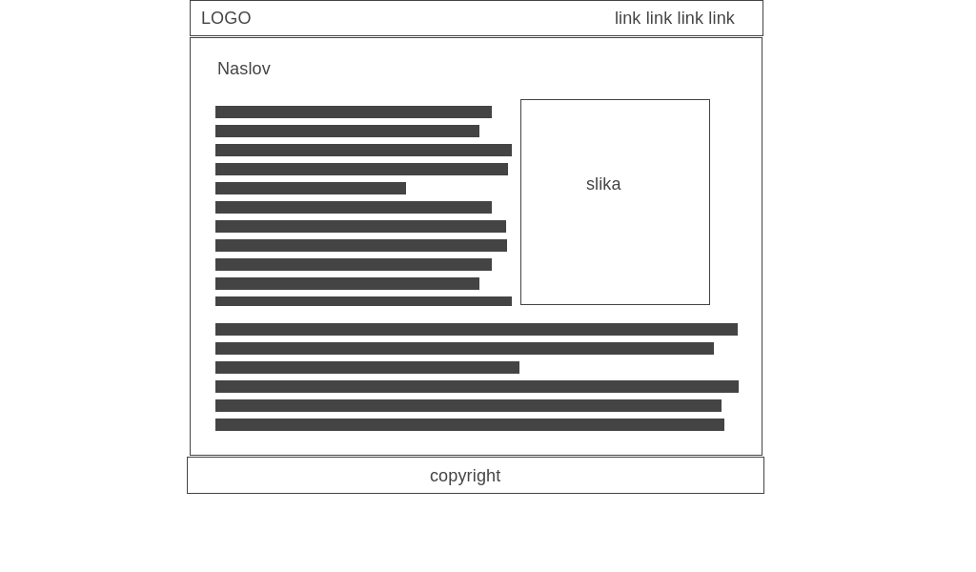

Slika 8 Predložak 1, stranica sa sadržajem

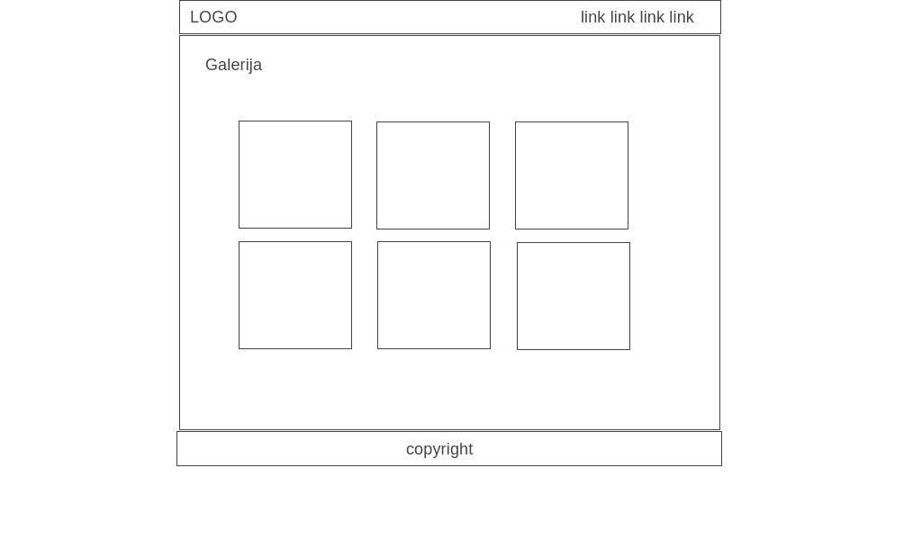

Slika 9 Predložak 1, galerija slika

Predložak 2:

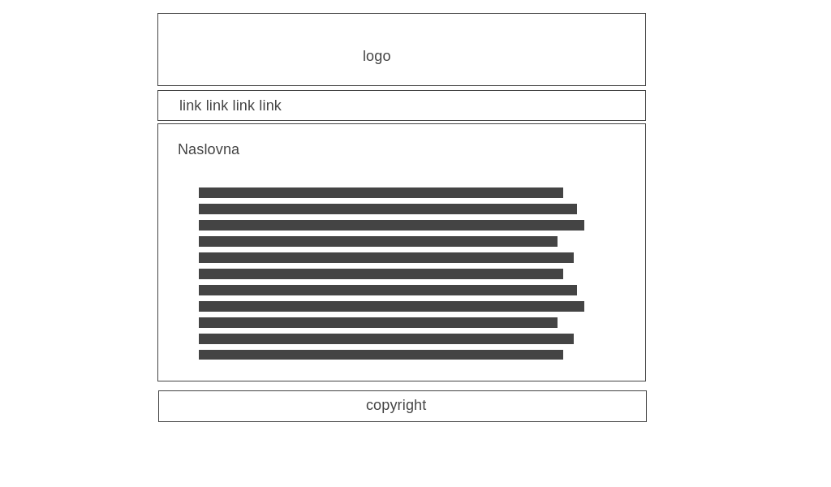

Slika 10 Predložak 2, naslovna

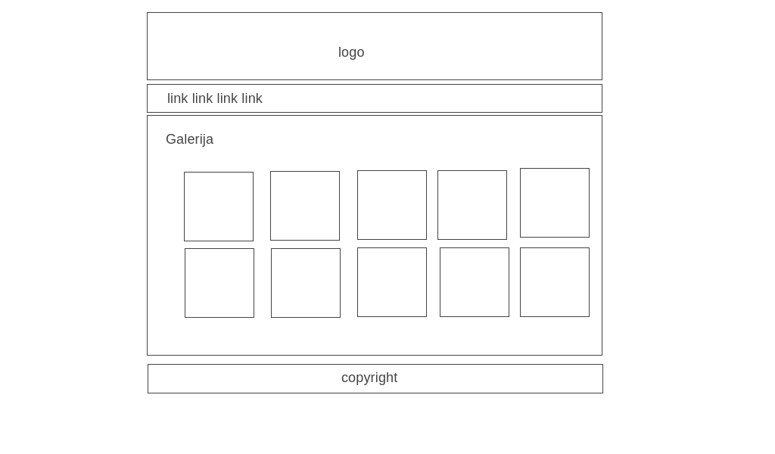

Slika 11 Predložak 2, galerija

Za izradu web mjesta sam odabrao predložak 1 jer su elementi raspoređeni bolje nego u drugom predložku. Drugi predložak ima više zastarjelu poziciju elemenata, na primjer logo je velika slika iznad izbornika, dok se u predlošku 1 logo nalazi s lijeve strane izbornika i ljepše izgleda. Drugi razlog za izbor prvog predloška je taj što se na naslovnoj stranici nalaze kartice koji se koriste kao sekundarni izbornik, to je praktično jer ima puno podstranica pa bi bilo previše stavki u padajućem izborniku i zbog toga bi bilo nepraktično i nepregledno za korisnika.

* + 1. ***Grafički dizajn***

***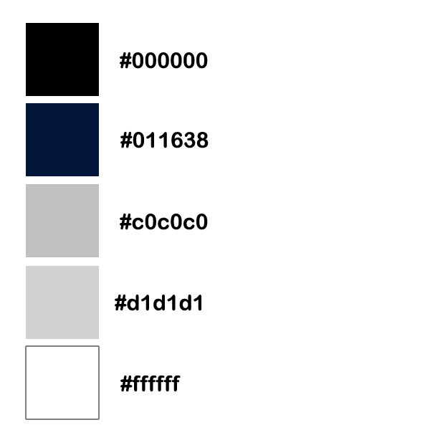***

Slika 12 Paleta boja

Game of Thrones logo je sive boje, pa kako bi se uskladio dizajn odabrane su 2 nijanse sive boja i jedna tamno plava kao primarne boje. Sive su odabrane jer odgovaraju boji loga, a tamno plava jer odgovara uz sivu boju. Također su tu bijela i crna boja, crna je predviđena za tekst, a bijela za neke manje dijelove stranica kako bi se razbila monotonija ili kako bi se neki dijelovi stranice naglasili.

Tipografija:

Kao primarni font je odabran Roboto.

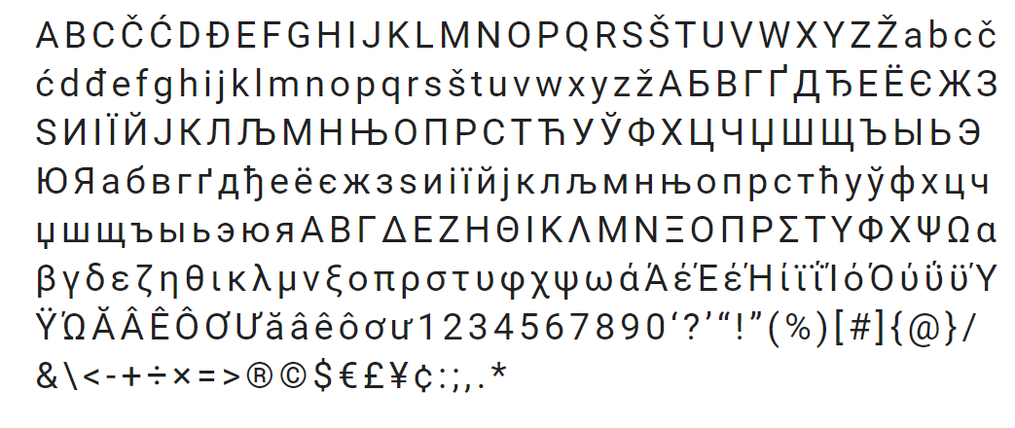

Izbornik će biti tamno plave boje (#011638) koja je prethodno definirana i s lijeve strane će se nalaziti logotip koji je sive boje. S desne strane se nalaze poveznice. Klikom na logotip se korisnik vraća na početnu stranicu. Poveznice u izborniku su sive boje, a kad se mišem pređe preko njih, mijenjaju boju u bijelu.

* 1. **Faza dizajna ili projektiranja**

***Mackup 1:***

***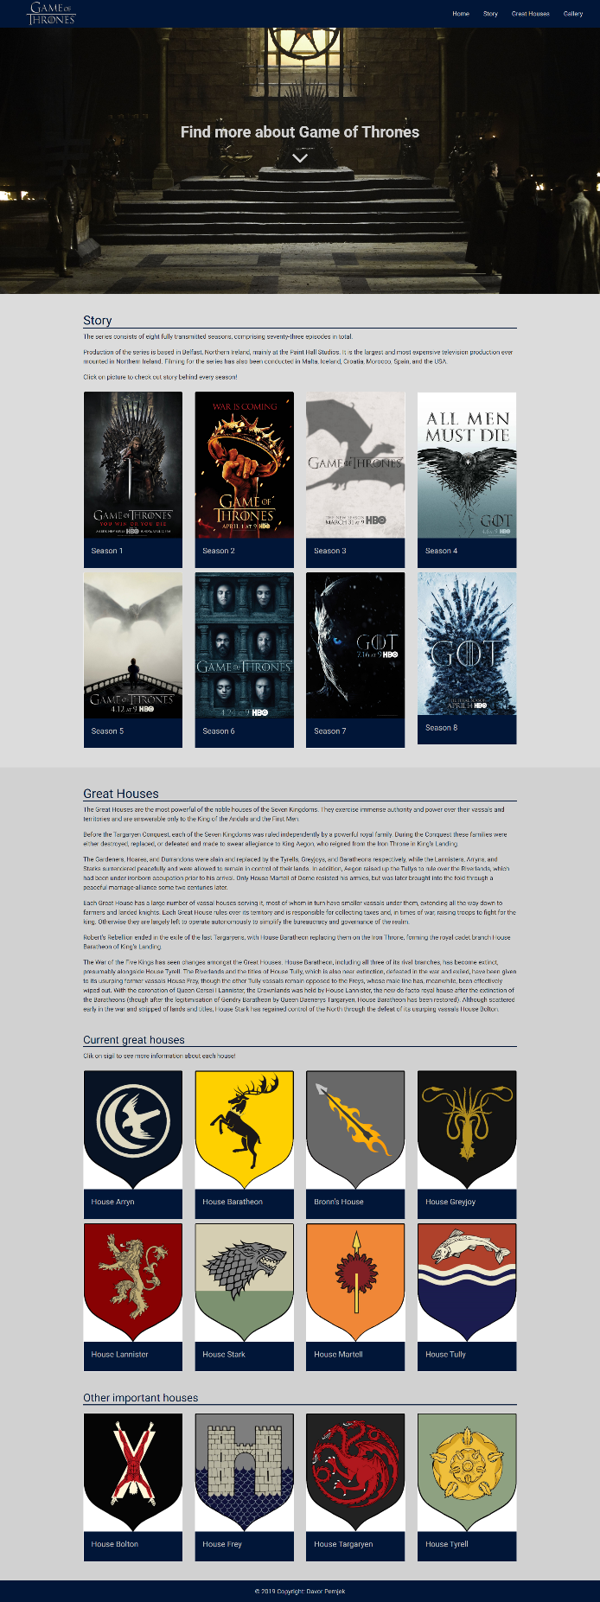***

Slika 13 Mockup 1, naslovna

***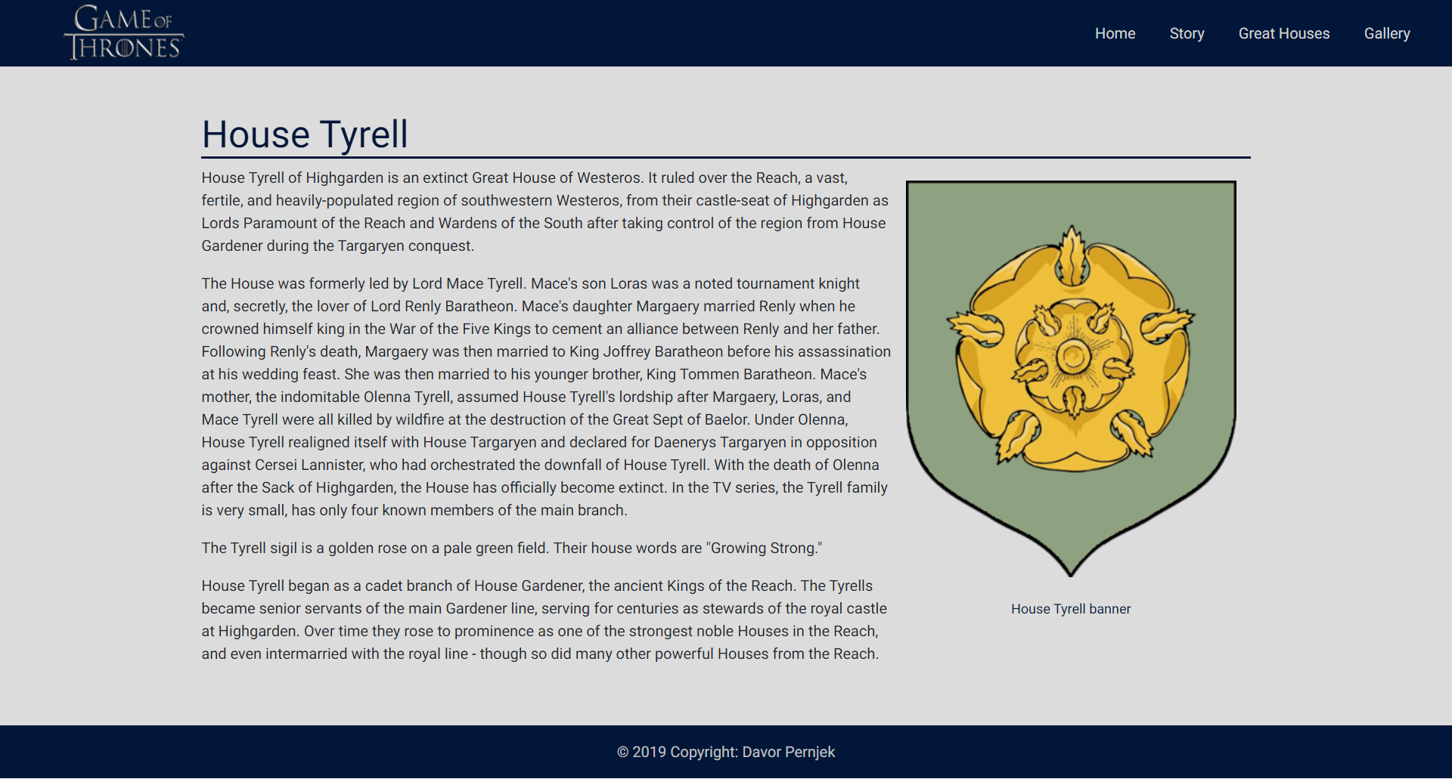***

Slika 14 Mockup 1, sadržaj

***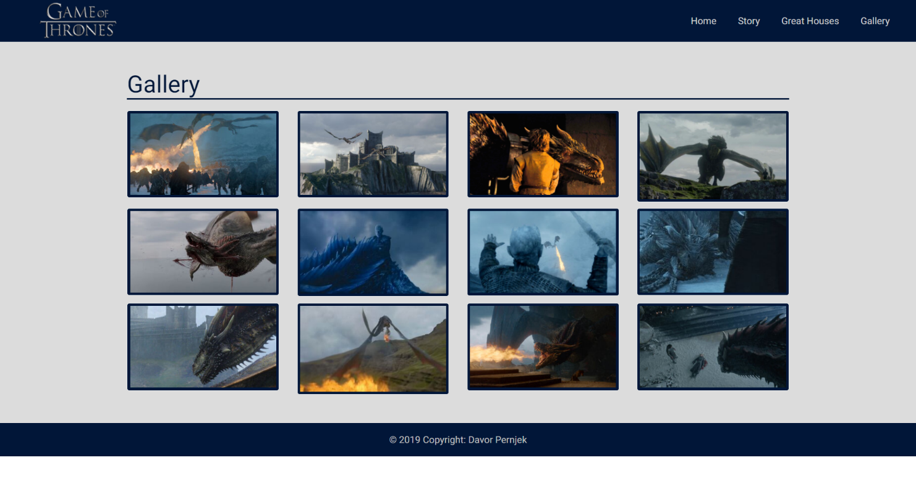***

Slika 15 Mockup 1, galerija

Mockup 2:

***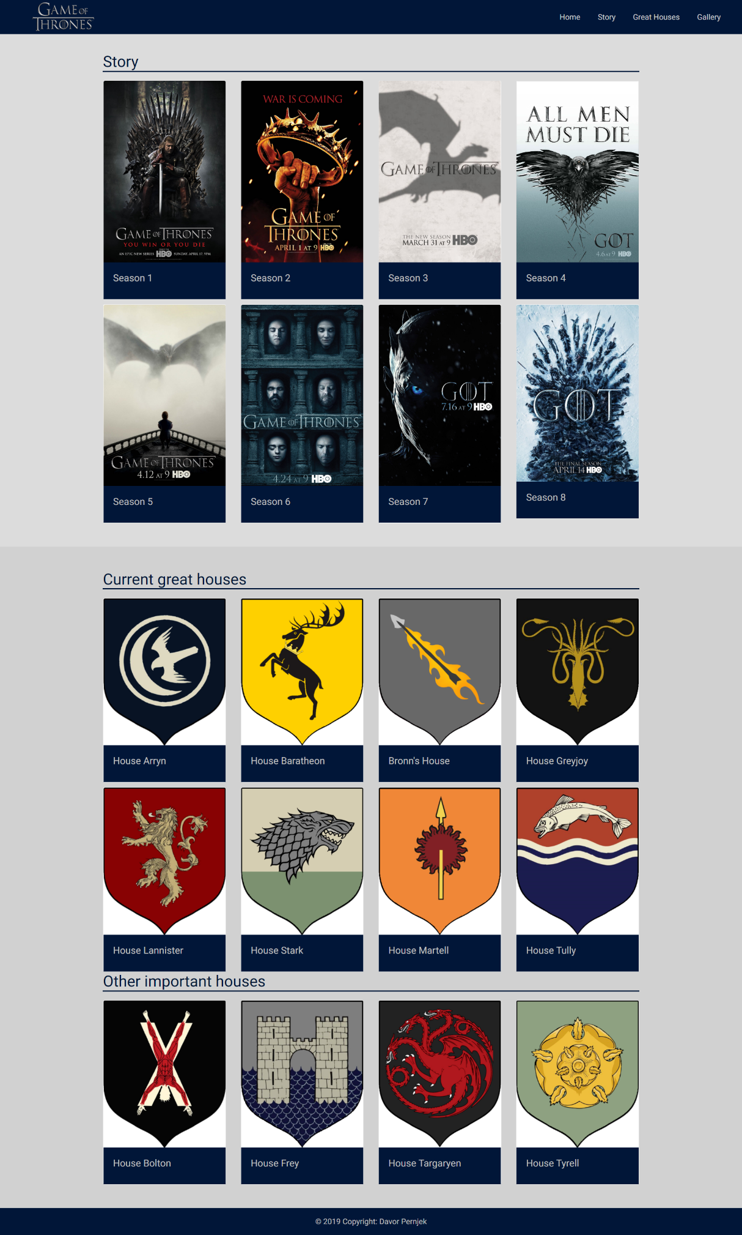***

Slika 16 Mockup 2 naslovna

***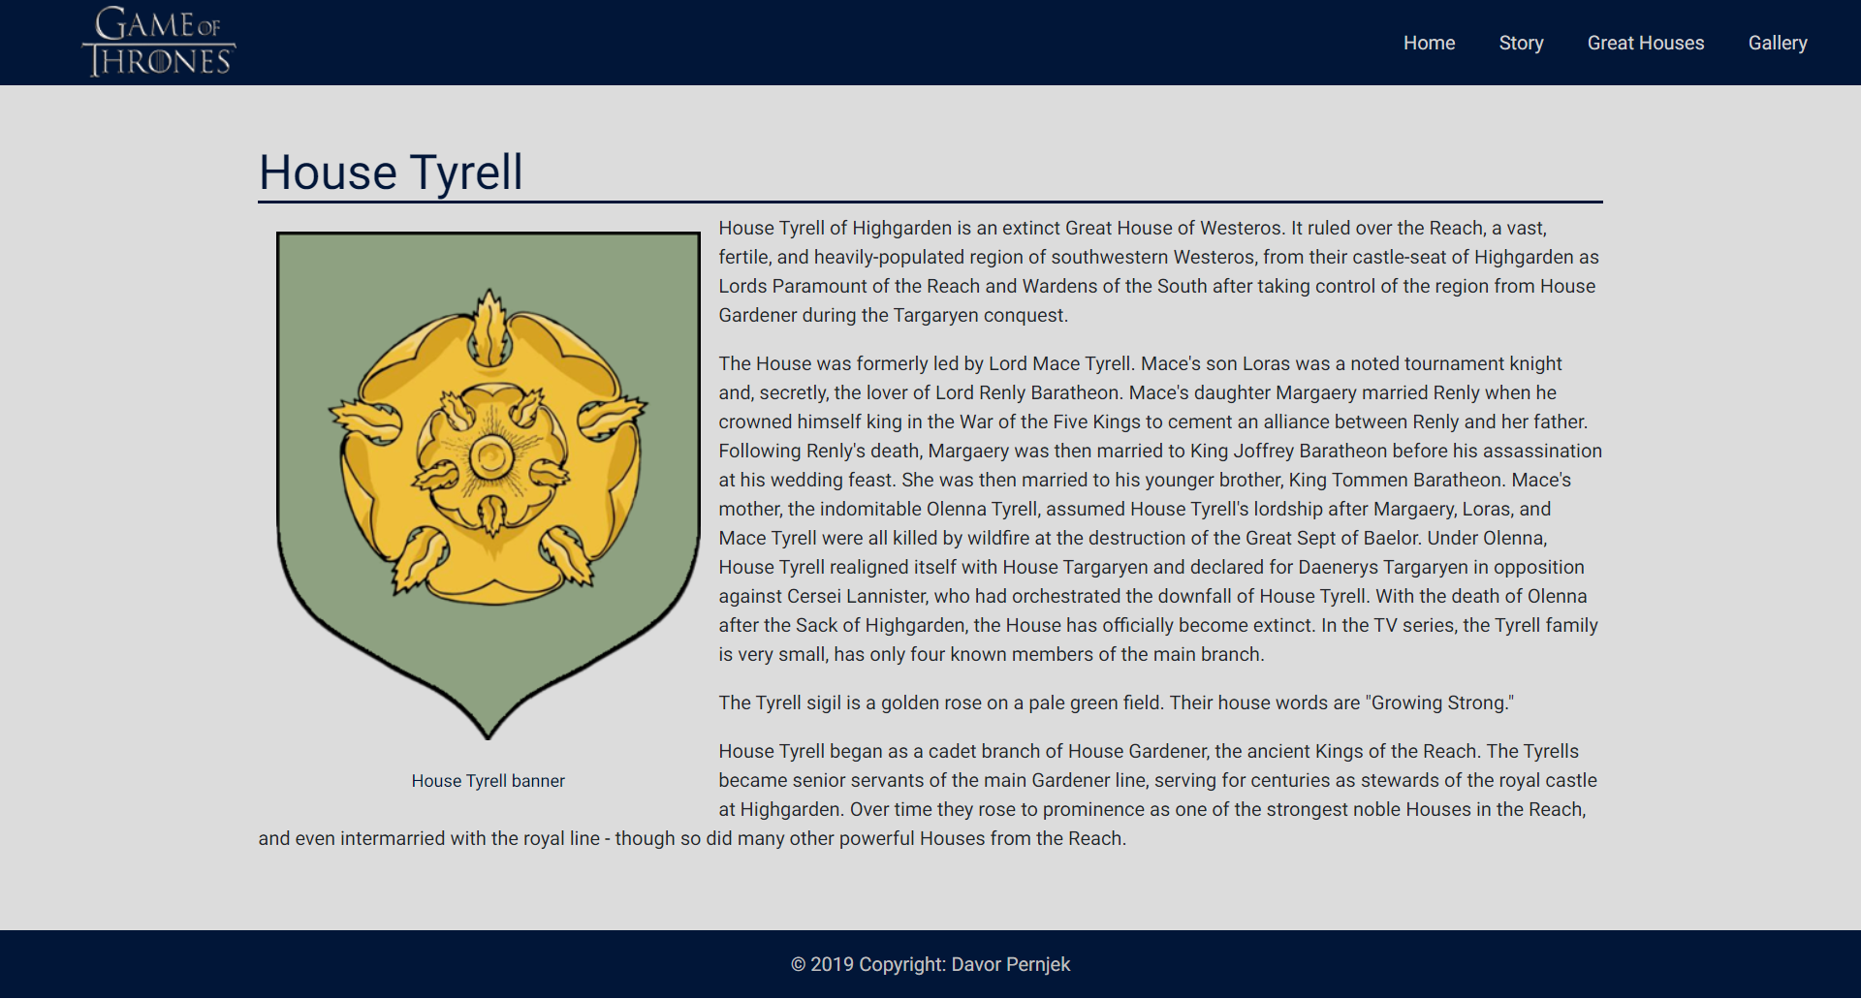***

Slika 17 Mockup 2 sadržaj

***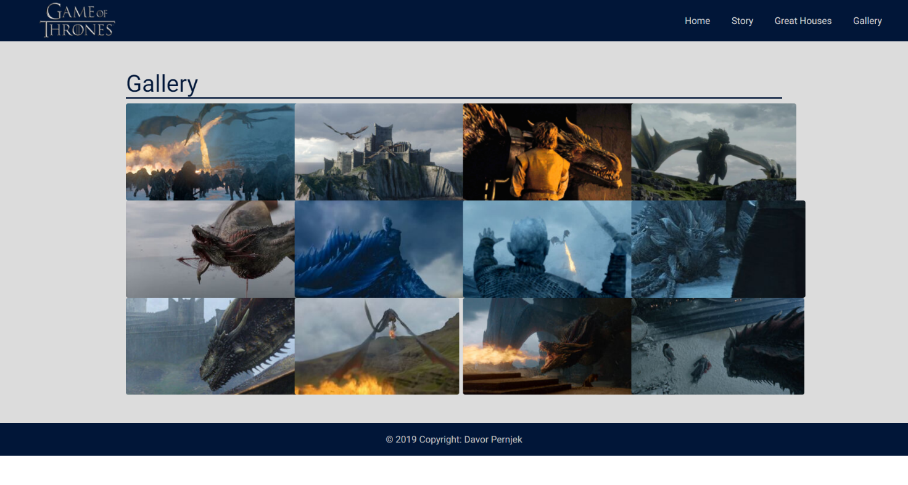***

Slika 18 Mockup 2 galerija

Odabrao sam mockup 1 jer na početnoj stranici ima naslovnu sliku koja je ugodna oku i poljepšava dizajn, stranice sa sadržajem imaju poravnate slike desno, izgleda prirodnije i lakše je čitati tekst nego kad je slika lijevo jer je onda samo distrakcija. Galerija ima razmake između slika, pa nije toliko zbunjujuće kao kod drugog mockup-a.

Ispod se nalazi dizajn prvog mockup-a za mobilne uređaje:

|  |  |  |
| --- | --- | --- |
| Slika 19 Dizajn za mobitele, naslovna | C:\Users\Davor\Downloads\screencapture-file-C-Users-Davor-Desktop-Game-of-Thrones-kopija-tyrell-html-2020-01-06-16_08_03.png  Slika 20 Dizajn za mobitele, sadržaj | C:\Users\Davor\Downloads\screencapture-file-C-Users-Davor-Desktop-Game-of-Thrones-kopija-gallery-html-2020-01-06-16_09_10.png  Slika 21 Dizajn za mobitele, galerija |

* 1. **Faza razvoja ili programiranja**

**HTML kod početne stranice:**

<!doctype html>

<html lang="en">

<head>

<!-- Font Roboto -->

<link href="https://fonts.googleapis.com/css?family=Roboto:400,400i,700&display=swap" rel="stylesheet">

<!-- Fontawesome -->

<link rel="stylesheet" href="https://cdnjs.cloudflare.com/ajax/libs/font-awesome/4.7.0/css/font-awesome.min.css">

<!-- Favicon -->

<link rel="icon" href="slike/favicon.png" type="image/png">

<!-- Posebni CSS -->

<link rel="stylesheet" type="text/css" href="stil.css">

<!-- Required meta tags -->

<meta charset="utf-8">

<meta name="viewport" content="width=device-width, initial-scale=1, shrink-to-fit=no">

<!-- Bootstrap CSS -->

<link rel="stylesheet" href="https://stackpath.bootstrapcdn.com/bootstrap/4.4.1/css/bootstrap.min.css" integrity="sha384-Vkoo8x4CGsO3+Hhxv8T/Q5PaXtkKtu6ug5TOeNV6gBiFeWPGFN9MuhOf23Q9Ifjh" crossorigin="anonymous">

<title>Game of Thrones</title>

</head>

<body>

<nav class="navbar fixed-top navbar-expand-sm navigacija">

<a class="navbar-brand" href="index.html"><img src="slike/logo\_navigacija.png" alt="Game of Thrones Logo"></a>

<button class="navbar-toggler" type="button" data-toggle="collapse" data-target="#navbarNav" aria-controls="navbarNav" aria-expanded="false" aria-label="Toggle navigation">

<span class="navbar-toggler-icon">

<i class="fa fa-navicon" style="color:#c0c0c0; font-size:28px;"></i>

</span>

</button>

<div class="collapse navbar-collapse justify-content-end" id="navbarNav">

<ul class="navbar-nav">

<li class="nav-item">

<a class="nav-link" href="index.html">Home</a>

</li>

<li class="nav-item">

<a class="nav-link" href="index.html#story">Story</a>

</li>

<li class="nav-item">

<a class="nav-link" href="index.html#greathouses">Great Houses</a>

</li>

<li class="nav-item">

<a class="nav-link" href="gallery.html">Gallery</a>

</li>

</ul>

</div>

</nav>

<div class="naslovna-slika">

<div class="container h-100">

<div class="row h-100 align-items-center">

<div class="col-12 text-center">

<h1 style="color: #D1D1D1; font-weight: bold; border-bottom: 0px solid black;">Find more about Game of Thrones</h1>

<a href="#story"><i class="fa fa-angle-down"></i></a>

</div>

</div>

</div>

</div>

<section class="py-5 sivi-bg1">

<a id="story" class="anchor"></a>

<div class="container">

<h2>Story</h2>

<p>The series consists of eight fully transmitted seasons, comprising seventy-three episodes in total.</p>

<p>Production of the series is based in Belfast, Northern Ireland, mainly at the Paint Hall Studios. It is the largest and most expensive television production ever mounted in Northern Ireland. Filming for the series has also been conducted in Malta, Iceland, Croatia, Morocco, Spain, and the USA.</p>

<p>Click on picture to check out story behind every season!</p>

<div class="row">

<div class="col-sm-3 justify-content-center">

<a href="season1.html">

<div class="card">

<img src="slike/sezona1\_poster.jpg" class="card-img-top" alt="Season 1 poster">

<div class="card-body">

<h5 class="card-title">Season 1</h5>

<p class="card-text"></p>

</div>

</div>

</a>

</div>

<div class="col-sm-3 justify-content-center">

<a href="season2.html">

<div class="card">

<img src="slike/sezona2\_poster.jpg" class="card-img-top" alt="Season 1 poster">

<div class="card-body">

<h5 class="card-title">Season 2</h5>

<p class="card-text"></p>

</div>

</div>

</a>

</div>

<div class="col-sm-3 justify-content-center">

<a href="season3.html">

<div class="card">

<img src="slike/sezona3\_poster.jpg" class="card-img-top" alt="Season 1 poster">

<div class="card-body">

<h5 class="card-title">Season 3</h5>

<p class="card-text"></p>

</div>

</div>

</a>

</div>

<div class="col-sm-3 justify-content-center">

<a href="season4.html">

<div class="card">

<img src="slike/sezona4\_poster.jpg" class="card-img-top" alt="Season 1 poster">

<div class="card-body">

<h5 class="card-title">Season 4</h5>

<p class="card-text"></p>

</div>

</div>

</a>

</div>

</div>

<div class="row">

<div class="col-sm-3 justify-content-center">

<a href="season5.html">

<div class="card">

<img src="slike/sezona5\_poster.jpg" class="card-img-top" alt="Season 1 poster">

<div class="card-body">

<h5 class="card-title">Season 5</h5>

<p class="card-text"></p>

</div>

</div>

</a>

</div>

<div class="col-sm-3 justify-content-center">

<a href="season6.html">

<div class="card">

<img src="slike/sezona6\_poster.jpg" class="card-img-top" alt="Season 1 poster">

<div class="card-body">

<h5 class="card-title">Season 6</h5>

<p class="card-text"></p>

</div>

</div>

</a>

</div>

<div class="col-sm-3 justify-content-center">

<a href="season7.html">

<div class="card">

<img src="slike/sezona7\_poster.jpg" class="card-img-top" alt="Season 1 poster">

<div class="card-body">

<h5 class="card-title">Season 7</h5>

<p class="card-text"></p>

</div>

</div>

</a>

</div>

<div class="col-sm-3 justify-content-center">

<a href="season8.html">

<div class="card">

<img src="slike/sezona8\_poster.jpg" class="card-img-top" alt="Season 1 poster">

<div class="card-body">

<h5 class="card-title">Season 8</h5>

<p class="card-text"></p>

</div>

</div>

</a>

</div>

</div>

</div>

</section>

<section class="py-5 sivi-bg">

<a id="greathouses" class="anchor"></a>

<div class="container">

<h2>Great Houses</h2>

<p>The Great Houses are the most powerful of the noble houses of the Seven Kingdoms. They exercise immense authority and power over their vassals and territories and are answerable only to the King of the Andals and the First Men.</p>

<p>Before the Targaryen Conquest, each of the Seven Kingdoms was ruled independently by a powerful royal family. During the Conquest these families were either destroyed, replaced, or defeated and made to swear allegiance to King Aegon, who reigned from the Iron Throne in King's Landing.</p>

<p>The Gardeners, Hoares, and Durrandons were slain and replaced by the Tyrells, Greyjoys, and Baratheons respectively, while the Lannisters, Arryns, and Starks surrendered peacefully and were allowed to remain in control of their lands. In addition, Aegon raised up the Tullys to rule over the Riverlands, which had been under ironborn occupation prior to his arrival. Only House Martell of Dorne resisted his armies, but was later brought into the fold through a peaceful marriage-alliance some two centuries later.</p>

<p>Each Great House has a large number of vassal houses serving it, most of whom in turn have smaller vassals under them, extending all the way down to farmers and landed knights. Each Great House rules over its territory and is responsible for collecting taxes and, in times of war, raising troops to fight for the king. Otherwise they are largely left to operate autonomously to simplify the bureaucracy and governance of the realm.</p>

<p>Robert's Rebellion ended in the exile of the last Targaryens, with House Baratheon replacing them on the Iron Throne, forming the royal cadet branch House Baratheon of King's Landing.</p>

<p>The War of the Five Kings has seen changes amongst the Great Houses. House Baratheon, including all three of its rival branches, has become extinct, presumably alongside House Tyrell. The Riverlands and the titles of House Tully, which is also near extinction, defeated in the war and exiled, have been given to its usurping former vassals House Frey, though the other Tully vassals remain opposed to the Freys, whose male line has, meanwhile, been effectively wiped out. With the coronation of Queen Cersei I Lannister, the Crownlands was held by House Lannister, the new de facto royal house after the extinction of the Baratheons (though after the legitimisation of Gendry Baratheon by Queen Daenerys Targaryen, House Baratheon has been restored). Although scattered early in the war and stripped of lands and titles, House Stark has regained control of the North through the defeat of its usurping vassals House Bolton.</p>

<h3>Current great houses</h3>

<p>Clik on sigil to see more information about each house!</p>

<div class="row">

<div class="col-sm-3 justify-content-center">

<a href="arryn.html">

<div class="card">

<img src="slike/arryn.png" class="card-img-top" alt="House Arryn">

<div class="card-body">

<h5 class="card-title">House Arryn</h5>

<p class="card-text"></p>

</div>

</div>

</a>

</div>

<div class="col-sm-3 justify-content-center">

<a href="baratheon.html">

<div class="card">

<img src="slike/baratheon.png" class="card-img-top" alt="House Baratheon">

<div class="card-body">

<h5 class="card-title">House Baratheon</h5>

<p class="card-text"></p>

</div>

</div>

</a>

</div>

<div class="col-sm-3 justify-content-center">

<a href="bronn.html">

<div class="card">

<img src="slike/bronn.png" class="card-img-top" alt="Bronn's House">

<div class="card-body">

<h5 class="card-title">Bronn's House</h5>

<p class="card-text"></p>

</div>

</div>

</a>

</div>

<div class="col-sm-3 justify-content-center">

<a href="greyjoy.html">

<div class="card">

<img src="slike/greyjoy.png" class="card-img-top" alt="House Greyjoy">

<div class="card-body">

<h5 class="card-title">House Greyjoy</h5>

<p class="card-text"></p>

</div>

</div>

</a>

</div>

</div>

<div class="row">

<div class="col-sm-3 justify-content-center">

<a href="lannister.html">

<div class="card">

<img src="slike/lannister.png" class="card-img-top" alt="House Lannister">

<div class="card-body">

<h5 class="card-title">House Lannister</h5>

<p class="card-text"></p>

</div>

</div>

</a>

</div>

<div class="col-sm-3 justify-content-center">

<a href="stark.html">

<div class="card">

<img src="slike/stark.png" class="card-img-top" alt="House Stark">

<div class="card-body">

<h5 class="card-title">House Stark</h5>

<p class="card-text"></p>

</div>

</div>

</a>

</div>

<div class="col-sm-3 justify-content-center">

<a href="martell.html">

<div class="card">

<img src="slike/martell.png" class="card-img-top" alt="House Martell">

<div class="card-body">

<h5 class="card-title">House Martell</h5>

<p class="card-text"></p>

</div>

</div>

</a>

</div>

<div class="col-sm-3 justify-content-center">

<a href="tully.html">

<div class="card">

<img src="slike/tully.png" class="card-img-top" alt="House Tully">

<div class="card-body">

<h5 class="card-title">House Tully</h5>

<p class="card-text"></p>

</div>

</div>

</a>

</div>

</div>

<h3>Other important houses</h3>

<div class="row">

<div class="col-sm-3 justify-content-center">

<a href="bolton.html">

<div class="card">

<img src="slike/bolton.png" class="card-img-top" alt="House Bolton">

<div class="card-body">

<h5 class="card-title">House Bolton</h5>

<p class="card-text"></p>

</div>

</div>

</a>

</div>

<div class="col-sm-3 justify-content-center">

<a href="frey.html">

<div class="card">

<img src="slike/frey.png" class="card-img-top" alt="House Frey">

<div class="card-body">

<h5 class="card-title">House Frey</h5>

<p class="card-text"></p>

</div>

</div>

</a>

</div>

<div class="col-sm-3 justify-content-center">

<a href="targaryen.html">

<div class="card">

<img src="slike/targaryen.png" class="card-img-top" alt="House Targaryen">

<div class="card-body">

<h5 class="card-title">House Targaryen</h5>

<p class="card-text"></p>

</div>

</div>

</a>

</div>

<div class="col-sm-3 justify-content-center">

<a href="tyrell.html">

<div class="card">

<img src="slike/tyrell.png" class="card-img-top" alt="House Tyrell">

<div class="card-body">

<h5 class="card-title">House Tyrell</h5>

<p class="card-text"></p>

</div>

</div>

</a>

</div>

</div>

</div>

</section>

<!-- Footer -->

<footer class="page-footer font-small dno">

<!-- Copyright -->

<div class="footer-copyright text-center py-3">© 2019 Copyright: Davor Pernjek

</div>

<!-- Copyright -->

</footer>

<!-- Footer -->

<!-- Optional JavaScript -->

<!-- jQuery first, then Popper.js, then Bootstrap JS -->

<script src="https://code.jquery.com/jquery-3.3.1.slim.min.js" integrity="sha384-q8i/X+965DzO0rT7abK41JStQIAqVgRVzpbzo5smXKp4YfRvH+8abtTE1Pi6jizo" crossorigin="anonymous"></script>

<script src="https://cdnjs.cloudflare.com/ajax/libs/popper.js/1.14.7/umd/popper.min.js" integrity="sha384-UO2eT0CpHqdSJQ6hJty5KVphtPhzWj9WO1clHTMGa3JDZwrnQq4sF86dIHNDz0W1" crossorigin="anonymous"></script>

<script src="https://stackpath.bootstrapcdn.com/bootstrap/4.3.1/js/bootstrap.min.js" integrity="sha384-JjSmVgyd0p3pXB1rRibZUAYoIIy6OrQ6VrjIEaFf/nJGzIxFDsf4x0xIM+B07jRM" crossorigin="anonymous"></script>

</body>

</html>

CSS kod:

.naslovna-slika {

height: 100vh;

min-height: 500px;

background-image: url('slike/logo\_naslovna.jpg');

background-size: cover;

background-position: center;

background-repeat: no-repeat;

}

.nav-item {

padding-right: 20px;

}

.navbar-brand {

margin-left: 50px;

}

.navigacija {

opacity: 1;

background-color:#011638;

}

.nav-link {

color: #D1D1D1;

}

.nav-link:hover {

color: white;

}

.fa {

color: #D1D1D1;

font-size: 70px;

}

h5 {

color: #c0c0c0;

}

h1, h2, h3, h4, h6 {

color: #011638;

}

h1, h2, h3 {

text-decoration: none;

font-weight: bold;

border-bottom: 2px solid #011638;

}

h3 {

margin-top:50px !important;

margin-bottom:10px !important;

}

body {

font-family: 'Roboto', sans-serif !important;

}

.sivi-bg {

background-color: #d1d1d1;

}

.sivi-bg1 {

background-color:#dcdcdc;

}

.card {

max-width:40rem;

margin-top:10px;

}

.card-body {

background-color:#011638;

}

.dno {

background-color:#011638;

color: #c0c0c0;

}

.navbar-toggler {

color: white;

z-index: 999999;

}

a.anchor{display: block; position: relative; top: -100px; visibility: hidden;}

@media only screen and (min-width: 577px) {

.navigacija {

height: 70px;

}

}

@media only screen and (max-width: 577px) {

a.anchor{display: block; position: relative; top: -150px; visibility: hidden;}

}

.slika {

padding: 15px;

}

.figure-caption {

color: #011638 !important;

}

.video {

-webkit-box-shadow: 7px 7px 16px -2px rgba(1,22,56,1);

-moz-box-shadow: 7px 7px 16px -2px rgba(1,22,56,1);

box-shadow: 7px 7px 16px -2px rgba(1,22,56,1);

}

.img-thumbnail {

cursor: pointer;

background-color:#011638 !important;

margin-top: 10px;

}

.thumb {

min-height: 160px;

}

* 1. **Faza testiranja**

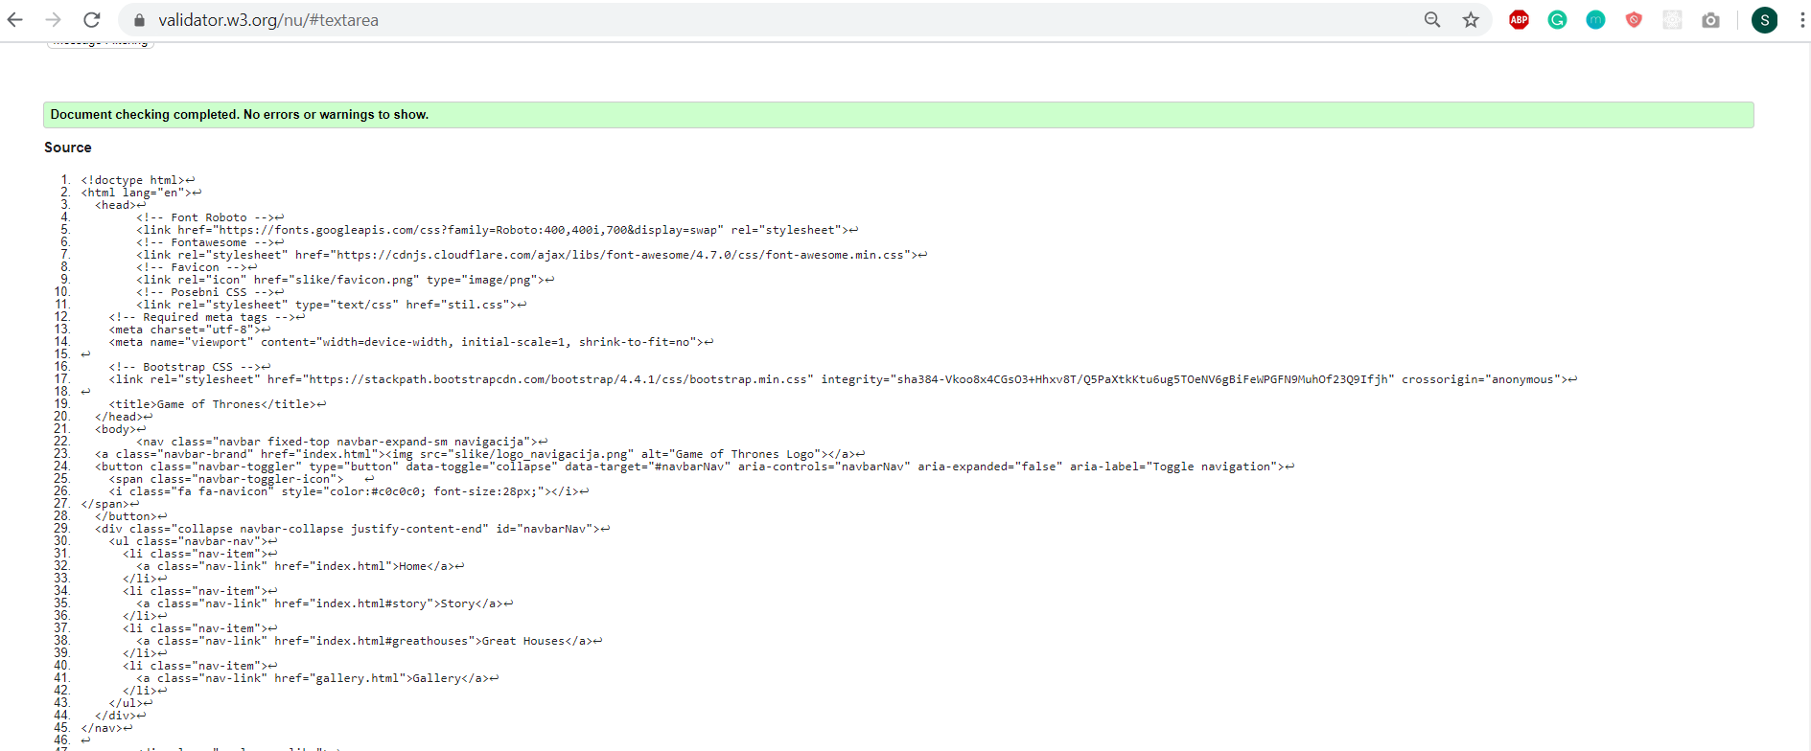

Slika 22 Slika zaslona HTML validatora (<https://validator.w3.org/>)

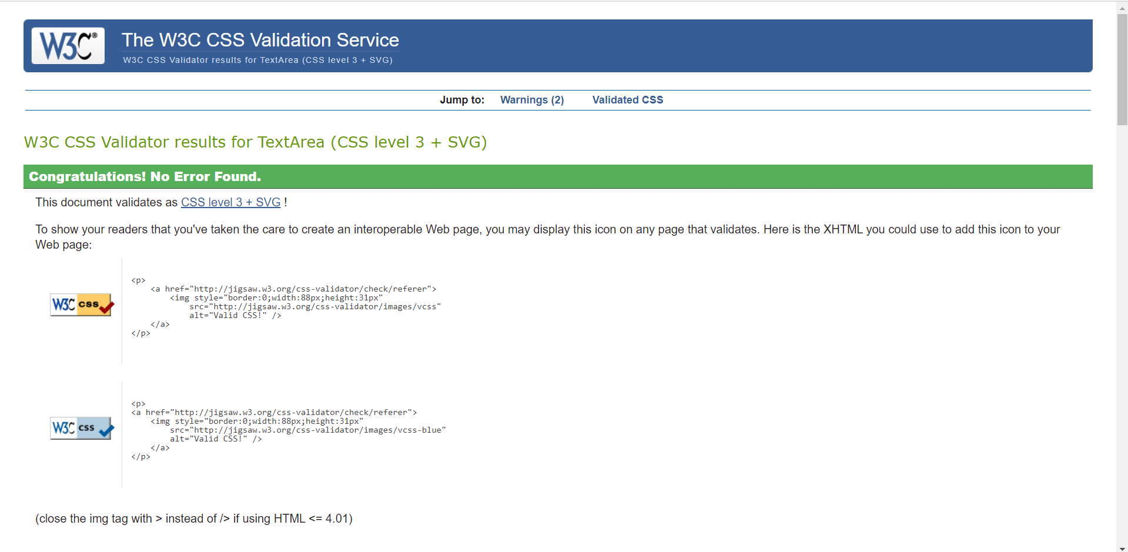

Slika 23 Slika zaslona CSS validatora (http://jigsaw.w3.org/css-validator/validator)

* 1. **Faza implementacija**

Beta verzija web stranica pušta se u rad i prezentira korisniku.

U ovoj fazi potrebno je napraviti kratku promociju web mjesta s opisom glavnih karakteristika aplikacije i nekoliko reprezentavtivnih screenshotova (konačne) verzije web stranica.